The impacts of the Eden Agreement on the Anglo-French Trade

A brief study of trade volumes, composition of trade, main commercial ports and prices

Corentin Ponton

[corentin.ponton@dauphine.eu](mailto:corentin.ponton@dauphine.eu) / Paris Dauphine University

# Introduction

The Anglo-French Commercial Treaty of 1786 marks the end of a customs war between Great Britain and France. The treaty, also called “Eden Treaty” in reference to the British negotiator of the treaty William Eden, opened the gates to a large increase in trade between the two countries despite a great deal of animosity between them. The “British consciousness has been built on hatred of France and French people”[1] (Colley 1993). Even in peace time a commercial rivalry grew during the eighteenth century and prevented commercial relationships until the Eden Treaty (Black 1986). Since 1713, Anglo-French commerce had been only regulated by the Treaty of Utrecht. Explications. But the reciprocal freedom of trade guaranteed by this agreement had never seen the light of day because Britain had not ratified the Articles 8 and 9 (Henderson 1957).

The origins of the treaty take roots in the Treaty of Paris signed in 1783 which ended the American Revolutionary War. The article 18 does indeed provide new trade arrangements between Great-Britain and France which would replace the moribund Commercial relationships of 1713. The initiator of this project is the French part, with Charles Gravier Comte de Vergennes (Heckscher 1922). He was a French statesman and diplomat who served as Foreign Minister from 1774 during the reign of Louis XVI, and he shared physiocratic views with other statesman and circles of influence. As this economic theory relies on the assumption that the wealth of nations only comes from agricultural land, Vergennes wanted to facilitate the development of trade with Great Britain which majority produce manufactured goods, to allow French economy to focus on agriculture. Moreover, the British economy could offer a potential further income stream for the French agriculture. In England, the idea of a trade agreement met sympathy thanks to the new ideas initiated by Adam Smith (Smith 1776). Industries also wished to increase sales and market shares in France because they feared that trade with America would collapse after the independence of the United States of America (Heckscher 1922).

Initially, the negotiations were time-consuming and lengthy. To accelerate the process, Versailles decided to prohibit numerous English goods: saddlery, hosiery, linens and hardware (Crouzet 2008). From this moment on, serious negotiations started between Gérard de Rayneval, the French commissioner, and William Eden, his British counterpart. According to F. Crouzet, Rayneval “was not up to the task”[2]. Indeed, he had the confidence of Vergennes but he had not a great knowledge in the field of economics. Maybe this fact may have play a key role in the final settlement of the treaty, because the British obtained practically all their demands, unlike their French counterparts.

The Eden agreement – signed on September 26th, 1786 – came into force on March 10th, 1787. The first articles concern trade facilitations. For example, there are provisions for the abolition of passports and the removal of restrictions on foreign traders (Henderson 1957). The article 6 deals with the new tariffs. It is decomposed in subparagraphs for each category of goods impacted by the agreement. All these categories are detailed in the Table 1 below, in the French and English version. Moreover, rates are defined in various ways in the article relating to the tariffs (Table 1).

Table 1: products impacted by the treaty and related tariffs

|  |  |  |  |
| --- | --- | --- | --- |
| **Category of good** | **Catégorie de biens** | **Custom duty type** | **Old/New tariff** |
| Wines of France | Vins de France | Specific tariff | 96 pounds, 4 Shillings per ton (EN)/  29 pounds, 8 shillings per ton |
| Vinegars of France | Vinaigre de France | Specific tariff | 67 pounds, 5 Shillings, 3 pence per ton (EN) /  32 pounds, 18 shillings, 10 pence per ton |
| The brandies of France | Eaux de vie de France | Specific tariff | 9 Shillings, 6 pence per gallon (EN) /  7 shillings per gallon |
| Oil of Olive of France | Huile d’olive de France | most favoured nation clause | ??? / most favoured nation clause |
| Beer | Bière | Ad valorem | ??? / 30% |
| Hardware, cutlery, cabinet ware and turnery | Quincaillerie, tabletterie et tous les ouvrages gros et menus de fer, acier, cuivre et airain. | Ad valorem | Prohibited / 10% |
| All sort of cottons manufactured | Cotons de toute espèce | Ad valorem | Prohibited / 12% |
| woollens, whether knit or wove | Lainages tant tricoté que tissés | Ad valorem | Prohibited / 12% |
| Cambrics and lawns | Toiles de batistes et linons | Specific tariff | ??? / 5 shillings per demi-piece of 7,75 yards |
| Linens | Toiles de lin et de chanvre | most favoured nation clause | ??? / most favoured nation clause |
| Sadlery | Sellerie | Ad valorem | ??? / 15% |
| Gauzes | Gazes | Ad valorem | ??? / 10% |
| Millinery | Modes | Ad valorem | ??? / 12% |
| Porcelain, earthen-ware and pottery | Porcelaine, faïence et poterie | Ad valorem | ??? / 12% |
| Plate-grafs and grafs | Glaces et verrerie | Ad valorem | ??? / 12% |

Note: (EN) indicates the British tariff

For the French, the main concessions of the treaty concerns the wines, vinegars, oils of live and brandies. As we can see, these products are all agricultural products which shows the physiocratic influence on the agreement[3]. However, the main problem is the absence of silk products in the treaty whereas the French silk industry was a key player in the French economy. For the British, the main concessions of the treaty concerns manufactured goods because a significant proportion of these products was prohibited before the treaty.

What have been the impacts of the treaty on the French economy and trade? Concerning trade, all studies show a rapid increase. In this study, I try to identify clearly the changes in Anglo-French trade patterns: volume and composition of trade, trend of prices and the effect on geographical influence. Concerning the effects on the economy, there is a very rigorous debate on this subject between historians. On the one hand, some economic historians argue that the Treaty was an economic burden for France. According to David Weir, “Trade liberalization in 1786 may have played an important role. It exposed the French industry to the British competition and lowered prices and production”[4] (Weir 1991). P. Verley mentioned an “economic disaster”[5] (Verley 1997). This is also the point of view of the contemporaries of the treaty. Heckscher explains that the Eden agreement was one of the main issue held against the *Ancien Régime* during the French Revolution (Heckscher 1922)*.* On the other hand, some historians recall that a serious commercial and industrial crisis started just before the Treaty (Crouzet 2008). Finally, J. Horn admits the negative impacts of the Treaty on the French economy at least in the short-term, but in the longer term the increase of trade could have a positive impact, especially through technology transfer. “In short, the Eden Treaty had drastic repercussions, but they were not solely negative; this survey illustrates that admits the devastation of the English flood tide of imports, there were justified reasons for cautious optimism about France’s long term ability to compete” (Horn 2006). But this debate will not be the substance of this paper, as this study is based on foreign trade data and not on output ones.

The paper is organized as follows. Section 2 describes the data in detail and presents the research project, called TOFLIT18, from which the data are drawn. Section 3 develops the methodology adopted for my analysis. Section 4 reports the empirical results from different analytical perspectives. Finally, section 5 suggests some conclusions.

# Data

## The TOFLIT 18 project

(This subsection is taken from an article published in the revue Dialogue (Ponton, Vidal & Daudin. 2016) )

The project intends to publish the most comprehensive database possible on French international trade from 1716 to 1828. The compilation of data in digital picture format has been a long process. The archives held by the French tax farms (which played the role of customs) were destroyed by the revolutionary fury. Fortunately, the administrators at the time often left their positions with part of their records, which ended up dispersed among different French and foreign collections of archives: the famous historian Posthumus, for example, compiled a collection from merchants selling old papers in Amsterdam in the 1930s.

Figure 1: Example of a trade register

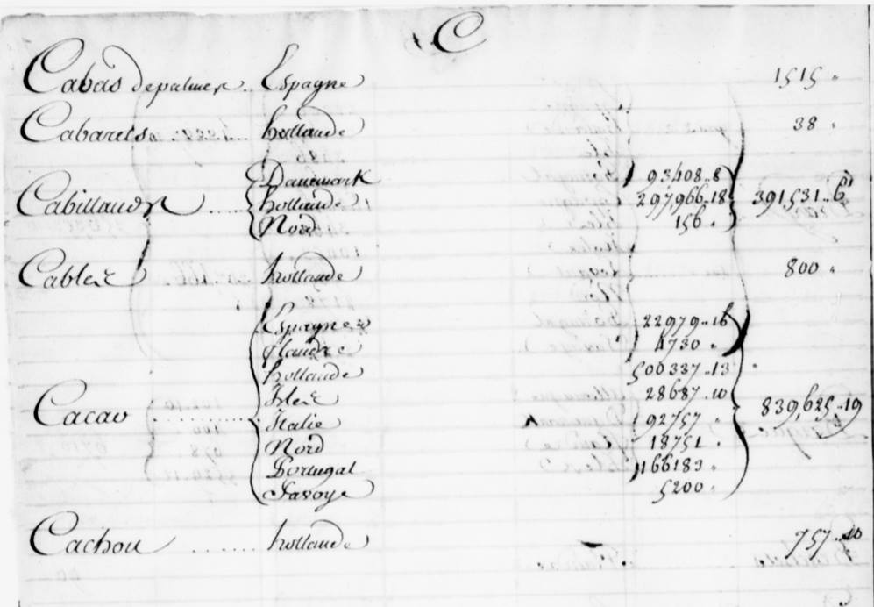

Note: General Register of Trade - 1757 – Rouen Municipal Library. TOFLIT18

The transcription of registers (generally handwritten, see the Figure 1 above) in the form of tables is much less rewarding work. A large team transcribed over 400,000 trade flows. Mistakes made by copyists at the time, geographic and historical variations in spelling, and human error by the transcribers made for a base that initially contained over 45,000 different goods and over 700 trade partners. The team therefore had to correct spellings and consolidate equivalent names (such as “herring” and “herring sea fish”) to harmonise the entries and bring the number of goods and partners down to 16,000 and 165 respectively. The team is now classifying the 16,000 goods in some 20 categories based on the UN’s SITC classification (Standard International Trade Classification). This is no mean task since a great deal of 18th century merchandise is hard to fit into these modern classifications. In fact, no classification can claim to be definitive so it is important to give everyone the possibility to alter the classifications, cross-check them, and so on.

1. Local and National sources

Two kinds of data are available with the sources: Local and National. They are not redundant because they offer different sets of information and advantages. National data – when available – are complete and compute all imports and/or exports for a given year (Daudin & Charles 2011). Trade data were aggregated by the *Bureau de la Balance de Commerce*. Local data are not complete for a given year (see Figure 2), because they are obtained from different locations, called “direction” (e.g. Bordeaux, Marseille, Nantes, etc.). But we can know the export or import location of goods with this source type. “National statistics are easier to use, but they usually bypass some of the information given in the local data”, and “Local statistics are better for geographical analysis” (Charles & Daudin 2015).

Figure 2

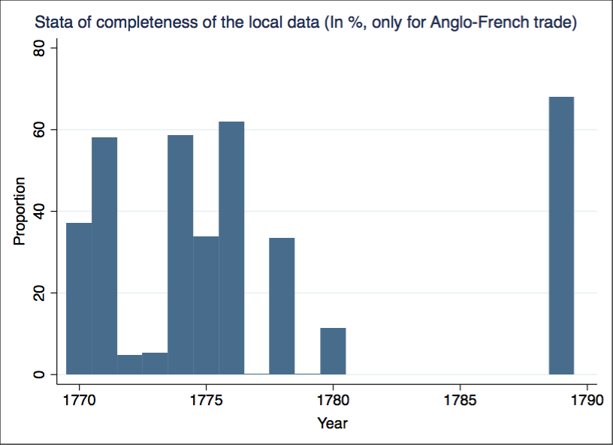

We have also specific trade data for the Anglo-French trade in 1783, 1784 and 1787 (only after the implementation of the treaty, i.e. from March). These trade data were built by the French government to measure the impacts of the Treaty. 1783 and 1784 have been added to the database, but 1787 have to be compared with the National source of 1787 before being added.

1. My database

To study the impacts of the Eden agreement on Anglo-French trade, I chose to constitute a subset of the whole dataset. I kept in my database French exports and imports with England only, and flows between 1770 and 1789. For National data, I have information for the periods 1770-1780, 1782-1784 and 1787-1789, for both exports and imports. For Local data, the availability of data depends of each direction as explained previously. The details are presented in Table 2 below.

Table 2: Availability of each direction by year

|  |  |  |
| --- | --- | --- |
| year | exportsimports | direction |
| 1770 | Exports | Bayonne, Bordeaux, La Rochelle |
|  | Imports | Bordeaux, La Rochelle, Bayonne |
| 1771 | Exports | Bayonne, Caen, La Rochelle, Nantes, Rouen |
|  | Imports | Bordeaux, La Rochelle, Nantes, Rennes, Rouen |
| 1772 | Exports | Bayonne, La Rochelle, Bayonne |
|  | Imports | Bayonne, La Rochelle |
| 1773 | Exports | Bayonne, La Rochelle |
|  | Imports | Bayonne, La Rochelle |
| 1774 | Exports | Bayonne, Bordeaux, Caen, La Rochelle, Nantes, Rouen |
|  | Imports | Bayonne, Bordeaux, La Rochelle, Nantes, Rennes, Rouen |
| 1775 | Exports | Bordeaux, La Rochelle |
|  | Imports | Bayonne, Bordeaux, La Rochelle, Nantes |
| 1776 | Exports | Bayonne, Bordeaux, Caen, La Rochelle, Nantes, Rouen |
|  | Imports | Bayonne, Bordeaux, Caen, La Rochelle, Nantes, Rennes, Rouen |
| 1777 | Imports | Bayonne |
| 1778 | Exports | Bayonne, Bordeaux, La Rochelle, Nantes |
|  | Imports | Bordeaux, La Rochelle, Rennes |
| 1779 | Imports | La Rochelle |
| 1780 | Imports | Bordeaux, La Rochelle, Rennes |
| 1789 | Exports | Amiens, Bayonne, Bordeaux, Caen, Lille, Lorient, Marseille, Nantes, Narbonne, Passeports, Rouen, Saint-Malo, Valenciennes |
| 1789 | Imports | Bordeaux, Charleville, Lille, Lorient, Marseille, Montpellier, Passeport du roy, Rouen, Saint-Malo |

Local data are much more complete for 1789 because an aggregation of all directions has been made by the *Bureau de la Balance de Commerce* for this given year. This source, called “National par direction”, can be found in the National Archives (AN).

# Method

In order to analyze Anglo-French trade, some treatments on the database were necessary. First, I created a new classification based on each category of goods impacted by the Eden agreement (see Table 1). Then, a standardization of the units of measurement was indispensable to compare flows and apply specific tariffs on goods. Finally, I used the “repeated sales” process, a regression applied in other studies on the Project (Pierre Hollegien, Elisa Tirindelli, Quentin Vidal) in order to estimate trade when data were missing.

1. The Eden classification

My classification is based on the categories of goods set out in the article 6 of the Treaty. In the database, these categories refer to a large number of goods, and it was easier to gather goods into classifications in order to follow it. The classification, called “Eden Treaty”, contain 17 groups of 343 items. A summary is proposed just below (Figure 3).

Figure 3: Summary of the "Eden Treaty"

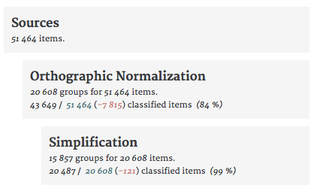

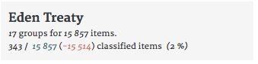

Note: The percentage of classified items is for the entire database and not only the Anglo-French trade

In addition, I create a category named “Prohibited”, for a few goods remaining prohibited after the Treaty: e.g. all manufactures of cotton or wool, mixed with silk; a category named “Silk product”, because although silk products are not impacted by the Treaty, the silk industry is still an important production for the French economy; and finally all other goods are gathered in a category “Other”.

It may be also appropriate to extend the classification to the whole database in order to know if the increase in trade of products impacted by the treaty is due to the reduction of the tariffs or only to an increase in international trade which does not reflect an impact of the Eden agreement.

1. Units of measurement

One of the biggest issues in the data was the standardization of the units of measurement. The quantity unit used in the archives depends on the year, the nature of the good and the region. But we need to work with a same unit for each category of the classification. In order to deal with this problem, I used and modified a script which converts these units in metric units (kilograms, liters, centimeters).

After the execution of the script, there are still problems with some flows without any quantity recorded. If we do not want to lose any information, it was necessary to predict the quantity of this flows thanks to the nature of the good, his value and the year of the exchange. This regression is similar to the “repeated sales” process. I created two set of dummies, year (t) and merchandise_simplification (i) (category of good in the “revised simplification classification”), and took an inverse price in order to run the following linear regression (1):

(1)

The resulting regression allows to predict the quantity for flows without this information, thanks to the following equation (2):

(2)

I used specifically this method for wines to compare my data with the ones of F. Crouzet as we will see in the next section. But the regression seems to be robust (Figure 4) and all coefficients are significant.

Figure 4: Regression (1) for Wines

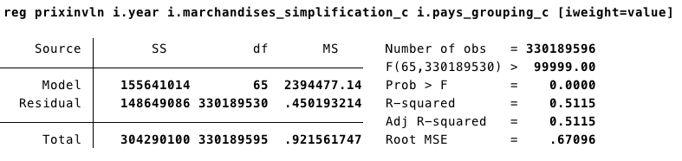

1. “Repeated sales” regression and prices

I also used the “repeated sales” process to analyze changes in prices. Indeed, if I want to know if the treaty had an impact on prices, I cannot only use existing flows and compare the mean of prices over year. Indeed, the Treaty could affect prices but also the composition of traded goods into a category (e.g. “Wines of France”). And if import duties decrease, maybe more low-quality wines – with lower prices – could be exported. This does not in any way mean that prices fall due to the Treaty.

To track the impact of the Treaty on prices, I needed to predict the evolution of the price for each good for a given group of goods (e.g. Wine of Bordeaux, Wine of Nantes, ordinary Wine: for “Wine of France”), even if a specific good is not sold for a particular year. As said before, I used once again the “repeated sales” process to have a price index for each year. With the regression (1), I obtained a coefficient for each year, then I could estimate the price index thanks to the following equation (3):

(3)

# Results

1. descriptive results

The principal consequence of the Treaty is a rapid increase of Anglo-French trade. For France, exports from England amounted to nearly 10% of the total exports in 1787, against figures of less than 5% before the Treaty (Figure 5). For the imports, changes are even more pronounced. Imports from England has climbed to 15% of total French imports in 1787, while at the height of the American Revolutionary War in 1780, imports from England were nearly non-existent (Figure 6).

Figure 5 Figure 6

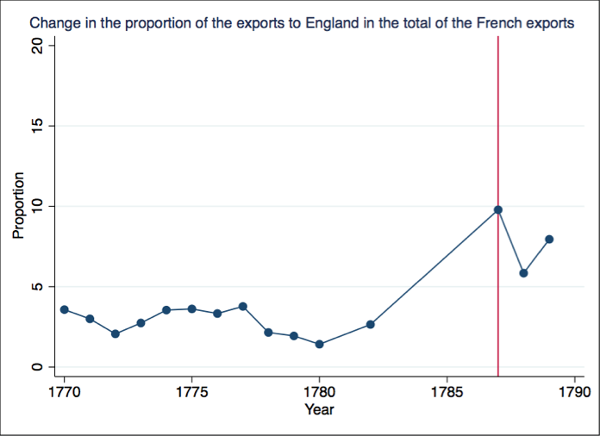 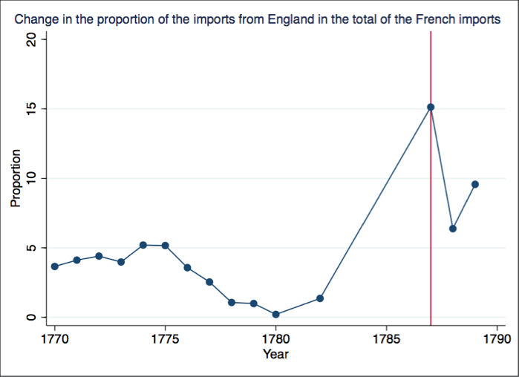

Figure 7 Figure 8

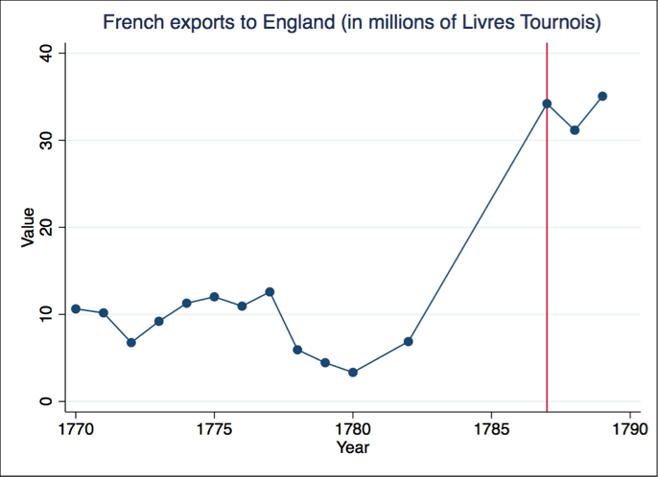 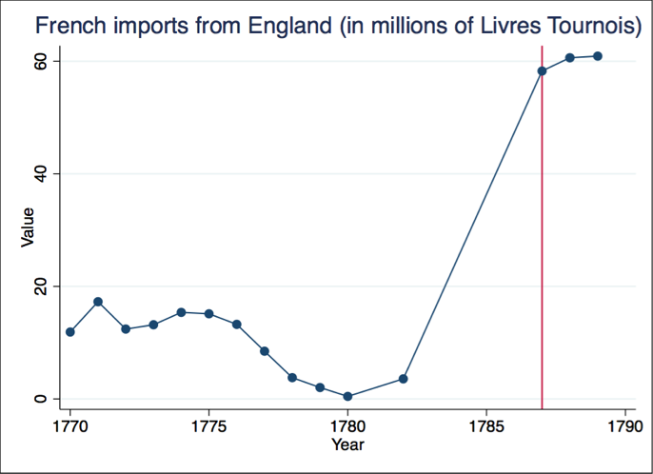

In value, both exports and imports increased with the Treaty, but imports grew more quickly than exports (Figure 7 & Figure 8). I chose to compare my results with the ones of M. Morineau (Morineau 1987). We can see below that the findings are similar (Table 3).

Table 3: Changes in exports and imports for the Anglo-French trade (in millions of Livres Tournois))

|  |  |  |
| --- | --- | --- |
| Year | Exports/Imports (M. Morineau) | Exports/Imports (TOFLIT18) |
| 1783 | No Data | 15.96 / 10.79 |
| 1784 | 20.0 / 13.2 | 22.97 / 10.30 |
| 1787 | 34.2 / 58.2 | 34.20 / 58.27 |
| 1788 | 31.2 / 63.7 | 31.15 / 60.62 |
| 1789 | 35.1 / 60.9 | 35.05 / 60.91 |

Imports grew faster than exports, leading to a deterioration in the trade balance, while the balance of trade position was positive before 1887 (Figure 9). The figure declines from a trade surplus of +5.16 millions of *Livres Tournois* in 1783 after the end of the war, to a trade deficit of -29.47 millions of *Livres Tournois* in 1788, one year after the implementation of the Eden agreement.

Figure 9

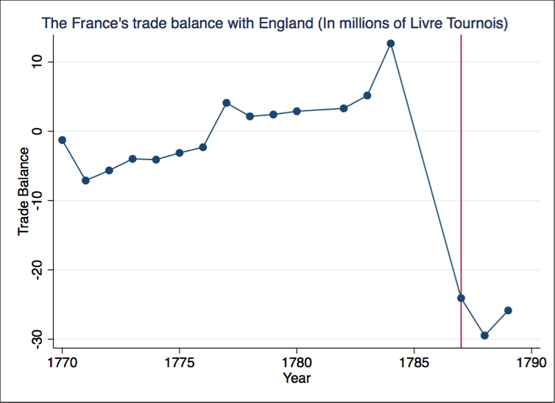

England became a major trade partner for France, while Anglo-French trade was very low just a few years earlier. As we can see below (Figure 10), England became in 1788 the second trade partner of France in terms of imports, placed just behind the French colonies. In term of exports, England became the fourth trade partner of France in 1787, behind North, Italy and Spain.

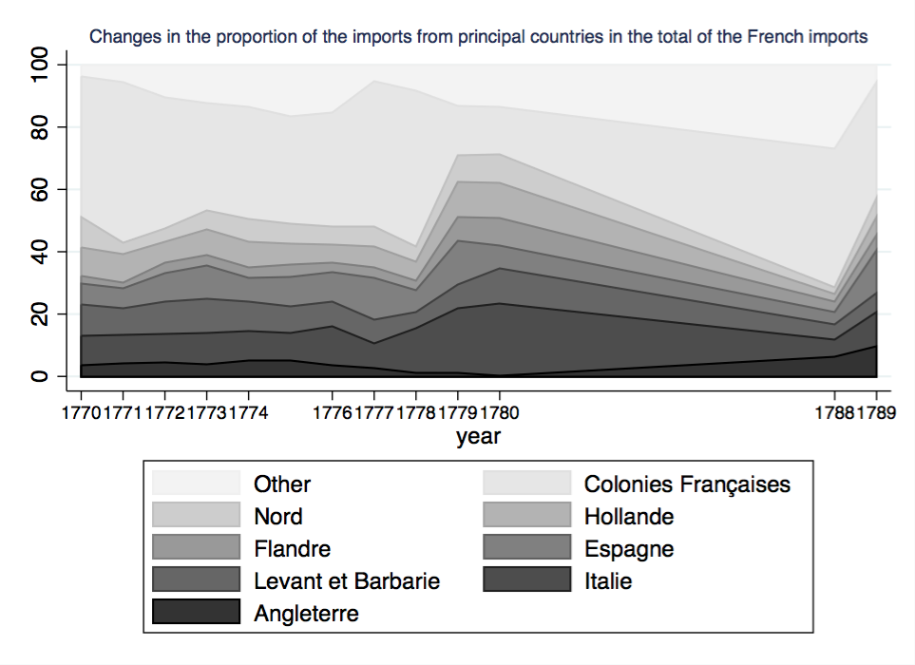Figure 10

1. Trade composition

Trade increased with the Treaty but another effect was a shift on the composition of trade. As we see in the literature review, Vergennes wanted to facilitate the development of trade with Great Britain in order to export farm products and imports manufactured ones, in the pure tradition of the physiocracy. My results seem to tell a same story. To study the composition of trade, I used the Standard International Trade Classification (SITC) in his third revision, a classification of goods made by the United Nations to classify the exports and imports of a country to enable comparing different countries and years.

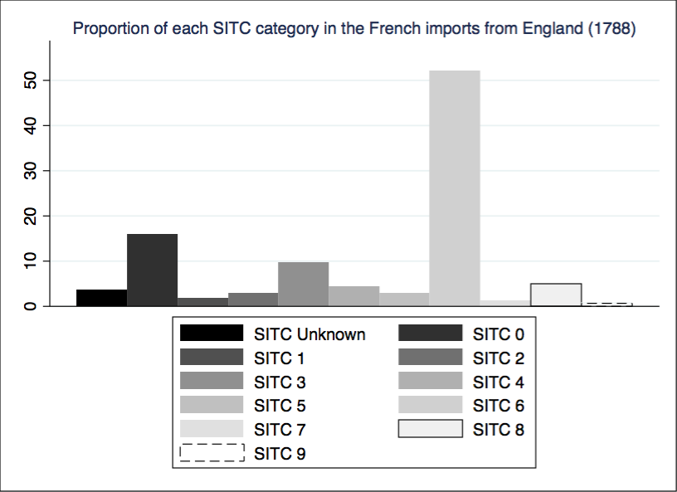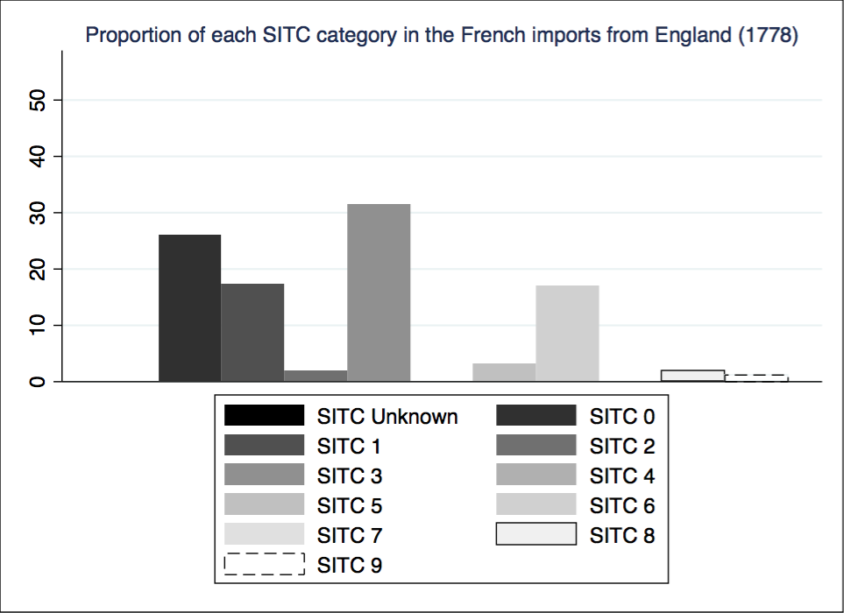For the exports of England to France, the export structure was more diversified in 1778 than in 1788. Indeed, England exported predominantly food and live animals (SITC 0), beverages and tobacco (SITC 1), mineral fuels, lubricants and related materials (SITC 3), and manufactured goods (SITC 6) in 1778 (Figure 11). But in 1788 (Figure 12), manufactured goods (SITC 6) accounted for a large part of the British exports to France (more than 50%).

Figure 12

Figure 11

For a better understanding of this new export structure, I looked into SITC 6 products to know precisely the products exported to France by England. The results are presented in the figure below (Figure 13). Most of the manufactured goods exported are metal products (34%, SITC 6j), cotton threads and fabrics (24%, SITC 6g), wool threads and fabrics (18%, SITC 6e) and silk threads and fabrics (13%, SITC 6f). This result was to be expected because metal products (Hardware, cutlery, cabinet ware, turnery), cotton products (all sort of cottons manufactured) and woollens (whether knit or wove) were impacted by the treaty.

Figure 13

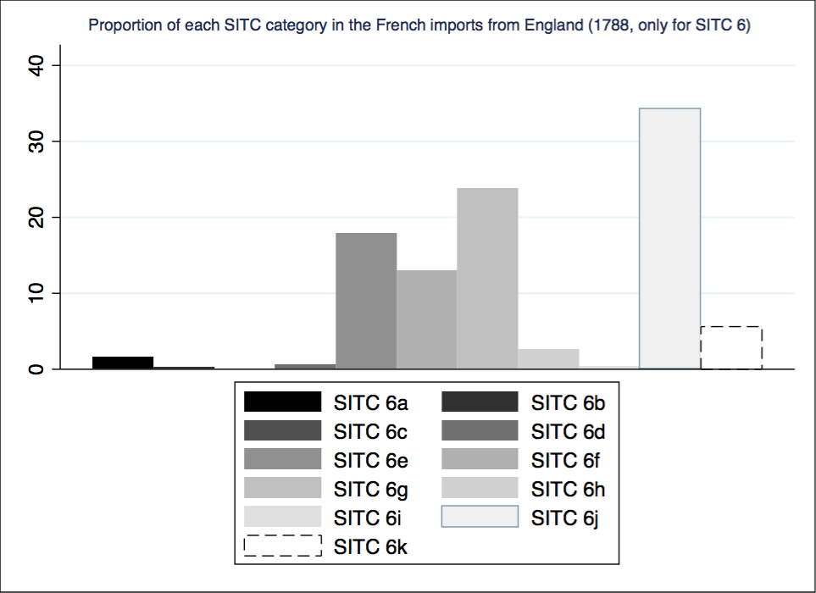

For the French exports, research findings are far less clear because an important share of goods are not classified in the SITC (more than 25%). But with the available information, we can see that between 1778 and 1788 manufactured products decrease in favour of raw materials (see Figure 14 &Figure 15). A large part of French exports to England are agricultural products as expected.

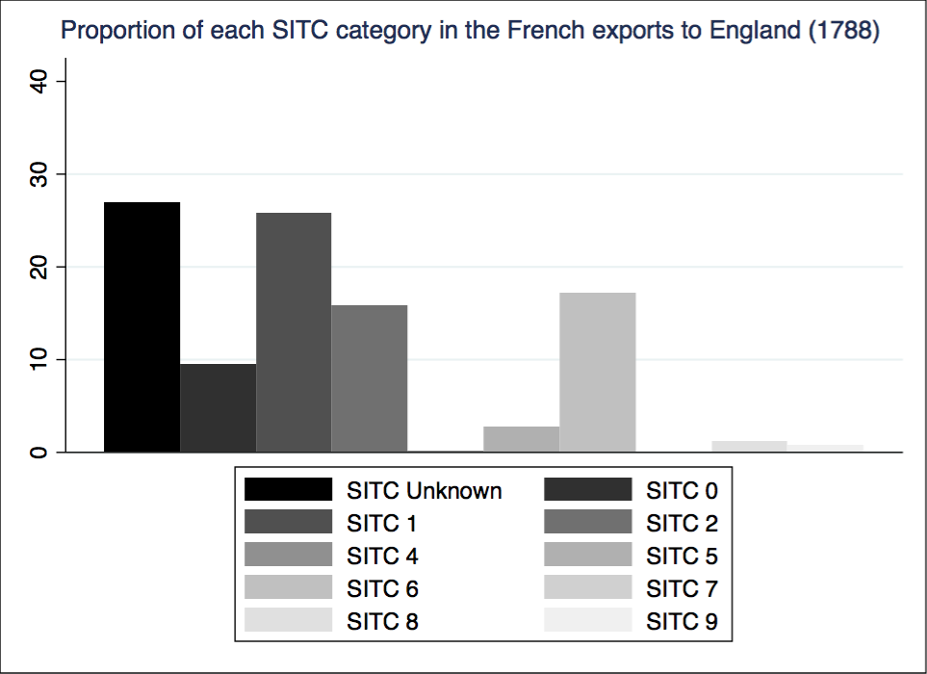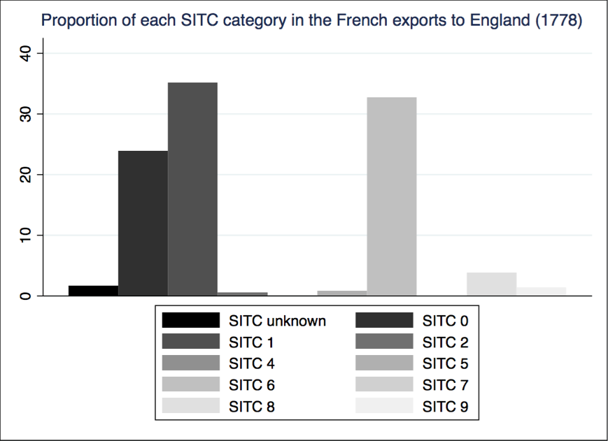

Figure 15

Figure 14

The different compositions of trade between exports and imports can explain the various trade balances for each product. For example, the French trade balance of brandies had a surplus of +10.46 millions of *Livres Tournois* in 1787 whereas the trade balance of cotton products had a deficit of -12.17 millions of *Livres Tournois* for the same year.

1. Directions

The Eden agreement has also impacted the importance of each direction in the Anglo-French trade. As I explained in the section 2, Local data are in parts fragmentary. For 1789 Local data are almost complete but before the Treaty, we have generally less than 40% of trade in value. This prevents us from tracking each direction before and after the treaty (with the exception of Bordeaux and Bayonne). Between 1778 and 1789, the share of the Anglo-French trade going through Bordeaux has decreased from 29.01% to 15.27% (see Figure 11).

In 1789, two years after the implementation of the treaty, Lille is the first direction in the Anglo-French trade in value among the available directions, thanks to the trade of cotton products and hardware (see Figure 12 and Figure 13). Indeed, respectively 42.39% and 44.78% of these exchanges go through the port of Lille, and these two products are the most affected by the treaty as we see previously.

Figure 11

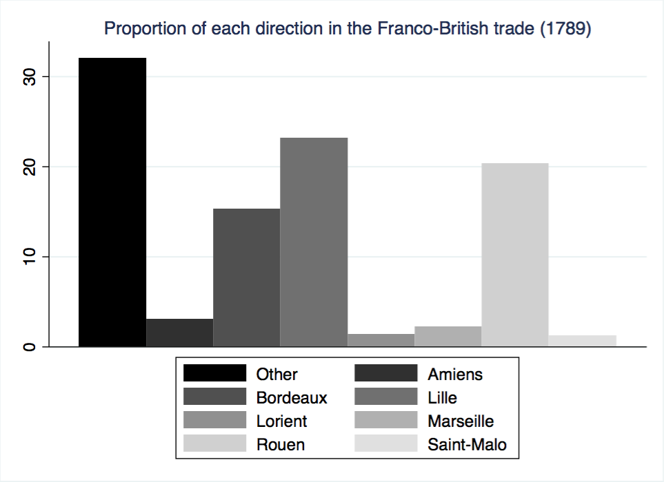

*Note: Direction with a proportion under 1% are hiden*

Figure 12 Figure 13

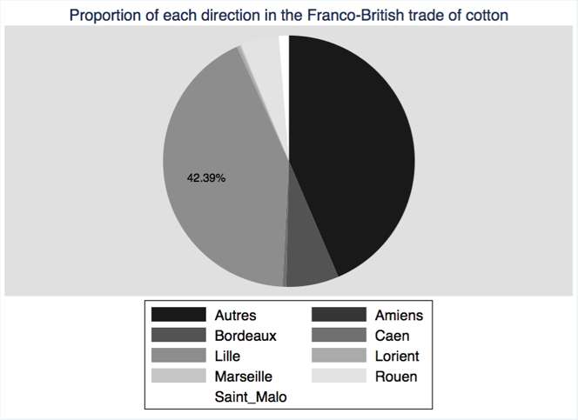 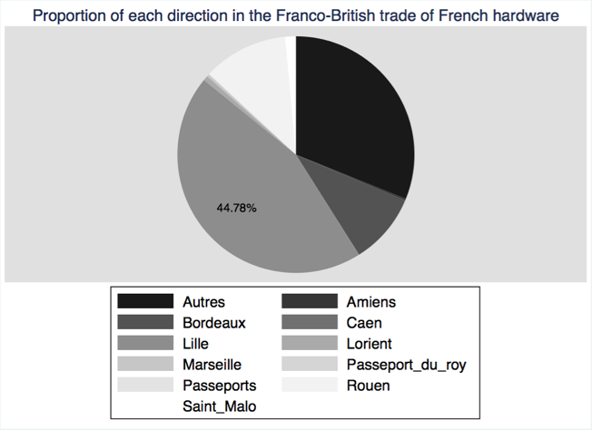

1. Prices

Finally, I tried to explore the issue of prices. I chose to study the changes in the price of wine because data are relatively complete and numerous. I used the “repeated sales” process mentioned in the Section 3.3 to make sure that I do not confuse changes in prices with changes in the composition of trade (e.g. more or less low-quality wines sold). My results are presented in the Figure 14 below and the Table 4 provides the regression results.

Figure 14

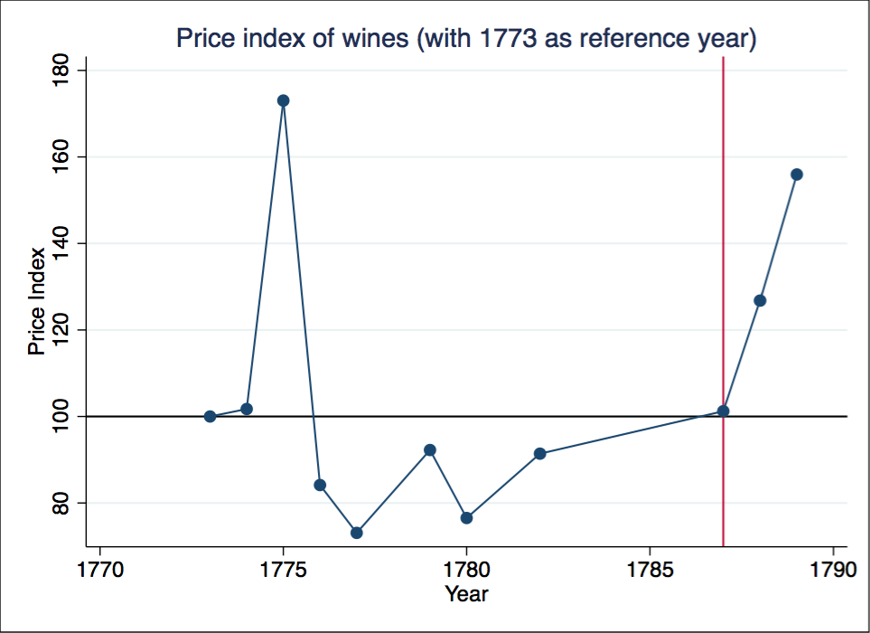

Table 4: Regression results in order to obtain the changes of the wine price index

|  |  |
| --- | --- |
| reg prixinvln i.year i.simplification_classification_c i.grouping_classification [iweight=value] | Modele (1) |
| VARIABLES |  |
| 1774.year | 0.0171*** |
|  | (0.000337) |
| 1775.year | 0.548*** |
|  | (0.000332) |
| 1776.year | -0.173*** |
|  | (0.000308) |
| 1777.year | -0.313*** |
|  | (0.000303) |
| 1779.year | -0.0807*** |
|  | (0.000363) |
| 1780.year | -0.268*** |
|  | (0.000586) |
| 1782.year | -0.0899*** |
|  | (0.00495) |
| 1787.year | 0.0122*** |
|  | (0.00330) |
| 1788.year | 0.237*** |
|  | (0.000299) |
| 1789.year | 0.444*** |
|  | (0.00188) |
| Constant | -7.746*** |
|  | (0.00220) |
| Observations | 24,395,227 |
| R-squared | 0.677 |

As a first observation, the price level may surprise readers as being really expensive. Indeed, E. Labrousse indicates that the price of a hectolitre of wine sold in France varied between 8.15 and 13.41 *Livres Tournois* (Labrousse 1933). But here the price of a tun of wine is, on average, 828 Livres Tournois, i.e. 90 *Livres Tournois* per hectolitre. This is 10 times more expensive that the price of wine sold in France! F. Crouzet explains that before the treaty, import duties were prohibitive and France exported only wines from great vintage (*Grand cru*) to England (Crouzet 2008). M. Braure postulates the same hypothesis: “More and more expensive wines are exported. (…) 800 to 1200 *Livres Tournois*, even 1500 in the second half of the century”[6] (Braure 1953).We can verify this assertion with the data (see

Figure 15). In 1787, 5.8% of wines are exported to England in terms of quantity (tuns), against 23.5% in terms of value (Livres Tournois). F. Crouzet finds respectively 9.4% and 31.5%. In another book (Crouzet 1968) he finds that the port of Bordeaux exported 7% of his wine to the British Islands for this year in terms of quantity. As Bordeaux represents 94.26% of the French exports of wine (in 1789), we can compare this figure with our results.

Figure 15

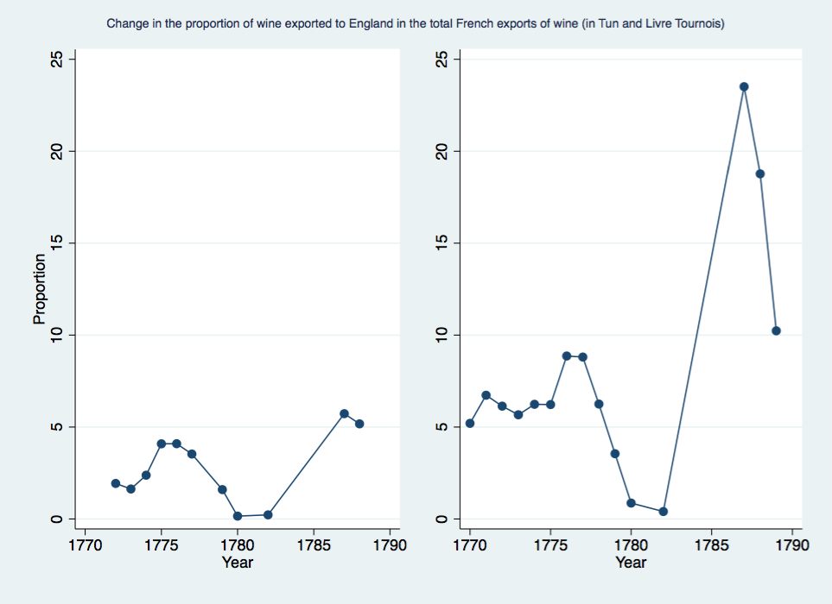

Note: In tun (left) and Livre Tournois (right)

Now, how we can interpret the increase of prices? After the reduction in the custom duties, French exporters had two possible options. The first one was to sell lowest-quality wines than before, because duties became less prohibitive, in order to gain market shares. This is a composition effect. Another one was to not change the composition of wines exported but to benefits from this reduction to increase the unit price of wines. Here, it seems that French wine industry decided to rise prices. I think that they have done so because the Portuguese wine was still more competitive. Indeed, after the Eden agreement, England lowered duties on Portuguese wines, in order to maintain the Methuen Treaty (Ludington 2013). This treaty stipulated that Portuguese wines imported into England would be subject to a third less duty than wines imported from France. French sellers could not expect to capture market share, and it is why they decided to increase prices.

Corentin Ponton

Black J. 1986. *Natural and Necessary Enemies: Anglo-French Relations in the Eighteenth Century*. Londres

Braure M. 1953. Quelques aspects des relations commerciales entre la France et l ’ Angleterre au XVIIIe siècle . Documents bordelais et leur interprétation. *Ann. du Midi Rev. archéologique, Hist. Philol. la Fr. méridionale*. 65(21):67–89

Charles L, Daudin G. 2015. Eighteenth-Century International Trade Statistics: Sources and Methods. *Rev. l’OFCE*. 140(Special issue):7–377

Colley L, Prall SE. 1993. Britons: Forging the Nation, 1707–1837. *Hist. Rev. New Books*. 22(1):35–35

Crouzet F. 1968. *Bordeaux Au XVIIIe Siècle (Extrait Du Tome V de l’Histoire de Bordeaux)*. Bordeaux

Crouzet F. 2008. *La Guerre Économique Franco-Anglaise Au 18e Siècle*. Fayard ed.

Daudin G, Charles L. 2011. La collecte du chiffre au XVIIIe siècle: le Bureau de la balance du commerce et la production des données sur le commerce extérieur de la France. *Rev. Hist. Mod. Contemp.* 58-1:128–55

Heckscher EF. 1922. *The Continental System: An Economic Interpretation,* Vol. 1. Harald Wes ed.

Henderson W. O. 1957. The Anglo-French Commercial Treaty of 1786. *Econ. Hist. Rev.* 10(1):104–12

Horn J. 2006. *The Path Not Taken - French Industrialization in the Age of Revolution (1750-1830)*. MIT Press ed.

Labrousse E. 1933. Tome I : Les prix. In *Esquisse Du Mouvement Des Prix et Des Revenus En Frause Au XVIIIe Siècle*, p. 724. Edition de ed.

Ludington C. 2013. *The Politics of Wine in Britain: A New Cultural History*. Palgrave Macmillan UK. Palgrave M ed.

Morineau M. 1987. *Pour Une Histoir Économique Vraie*. Lille

Ponton C, Vidal Q, Daudin G. 2016. HISTORICAL ANALYSIS OF FRANCE’S FOREIGN TRADE - THE TOFLIT 18 PROJECT. *Dialogue Can. Philos. Assoc.* (43):1–9

Smith A. 1776. *The Wealth of Nations*, Vol. 2

Verley P. 1997. *L’Échelle Du Monde. Essai Sur l’Industrialisation de l’Occident*. Paris. Gallimard ed.

Weir DR. 1991. Les crises économiques et les origines de la Révolution française. *Ann. Économies, Sociétés, Civilisations*. 46e année(N. 4,):917–47

1. « (…) la conscience nationale britannique s’est forgée dans la haine de la France et des français. »
2. « Il ne devait pas être à la hauteur de sa tâche »
3. Here we will consider wine, beer and brandies as agricultural products
4. « La libéralisation du commerce en 1786 peut fort bien avoir joué un rôle important. Elle exposa l’industrie française à la concurrence britannique et abaissa les prix et la production »
5. « Naufrage industriel »
6. « Ce sont des vins de plus en plus chers qu'on expédie. (…) On atteint 800 à 1.200 livres, voire 1.500 dans la seconde moitié du siècle. »